**Module 6 Conditionals**

**Part 1 Travelling by plane**

**Read Danny’s blog. What happened to him on the plane?**

**Look at the highlighted grammar examples. Do they describe future, present or past situations; real or unreal situations?**

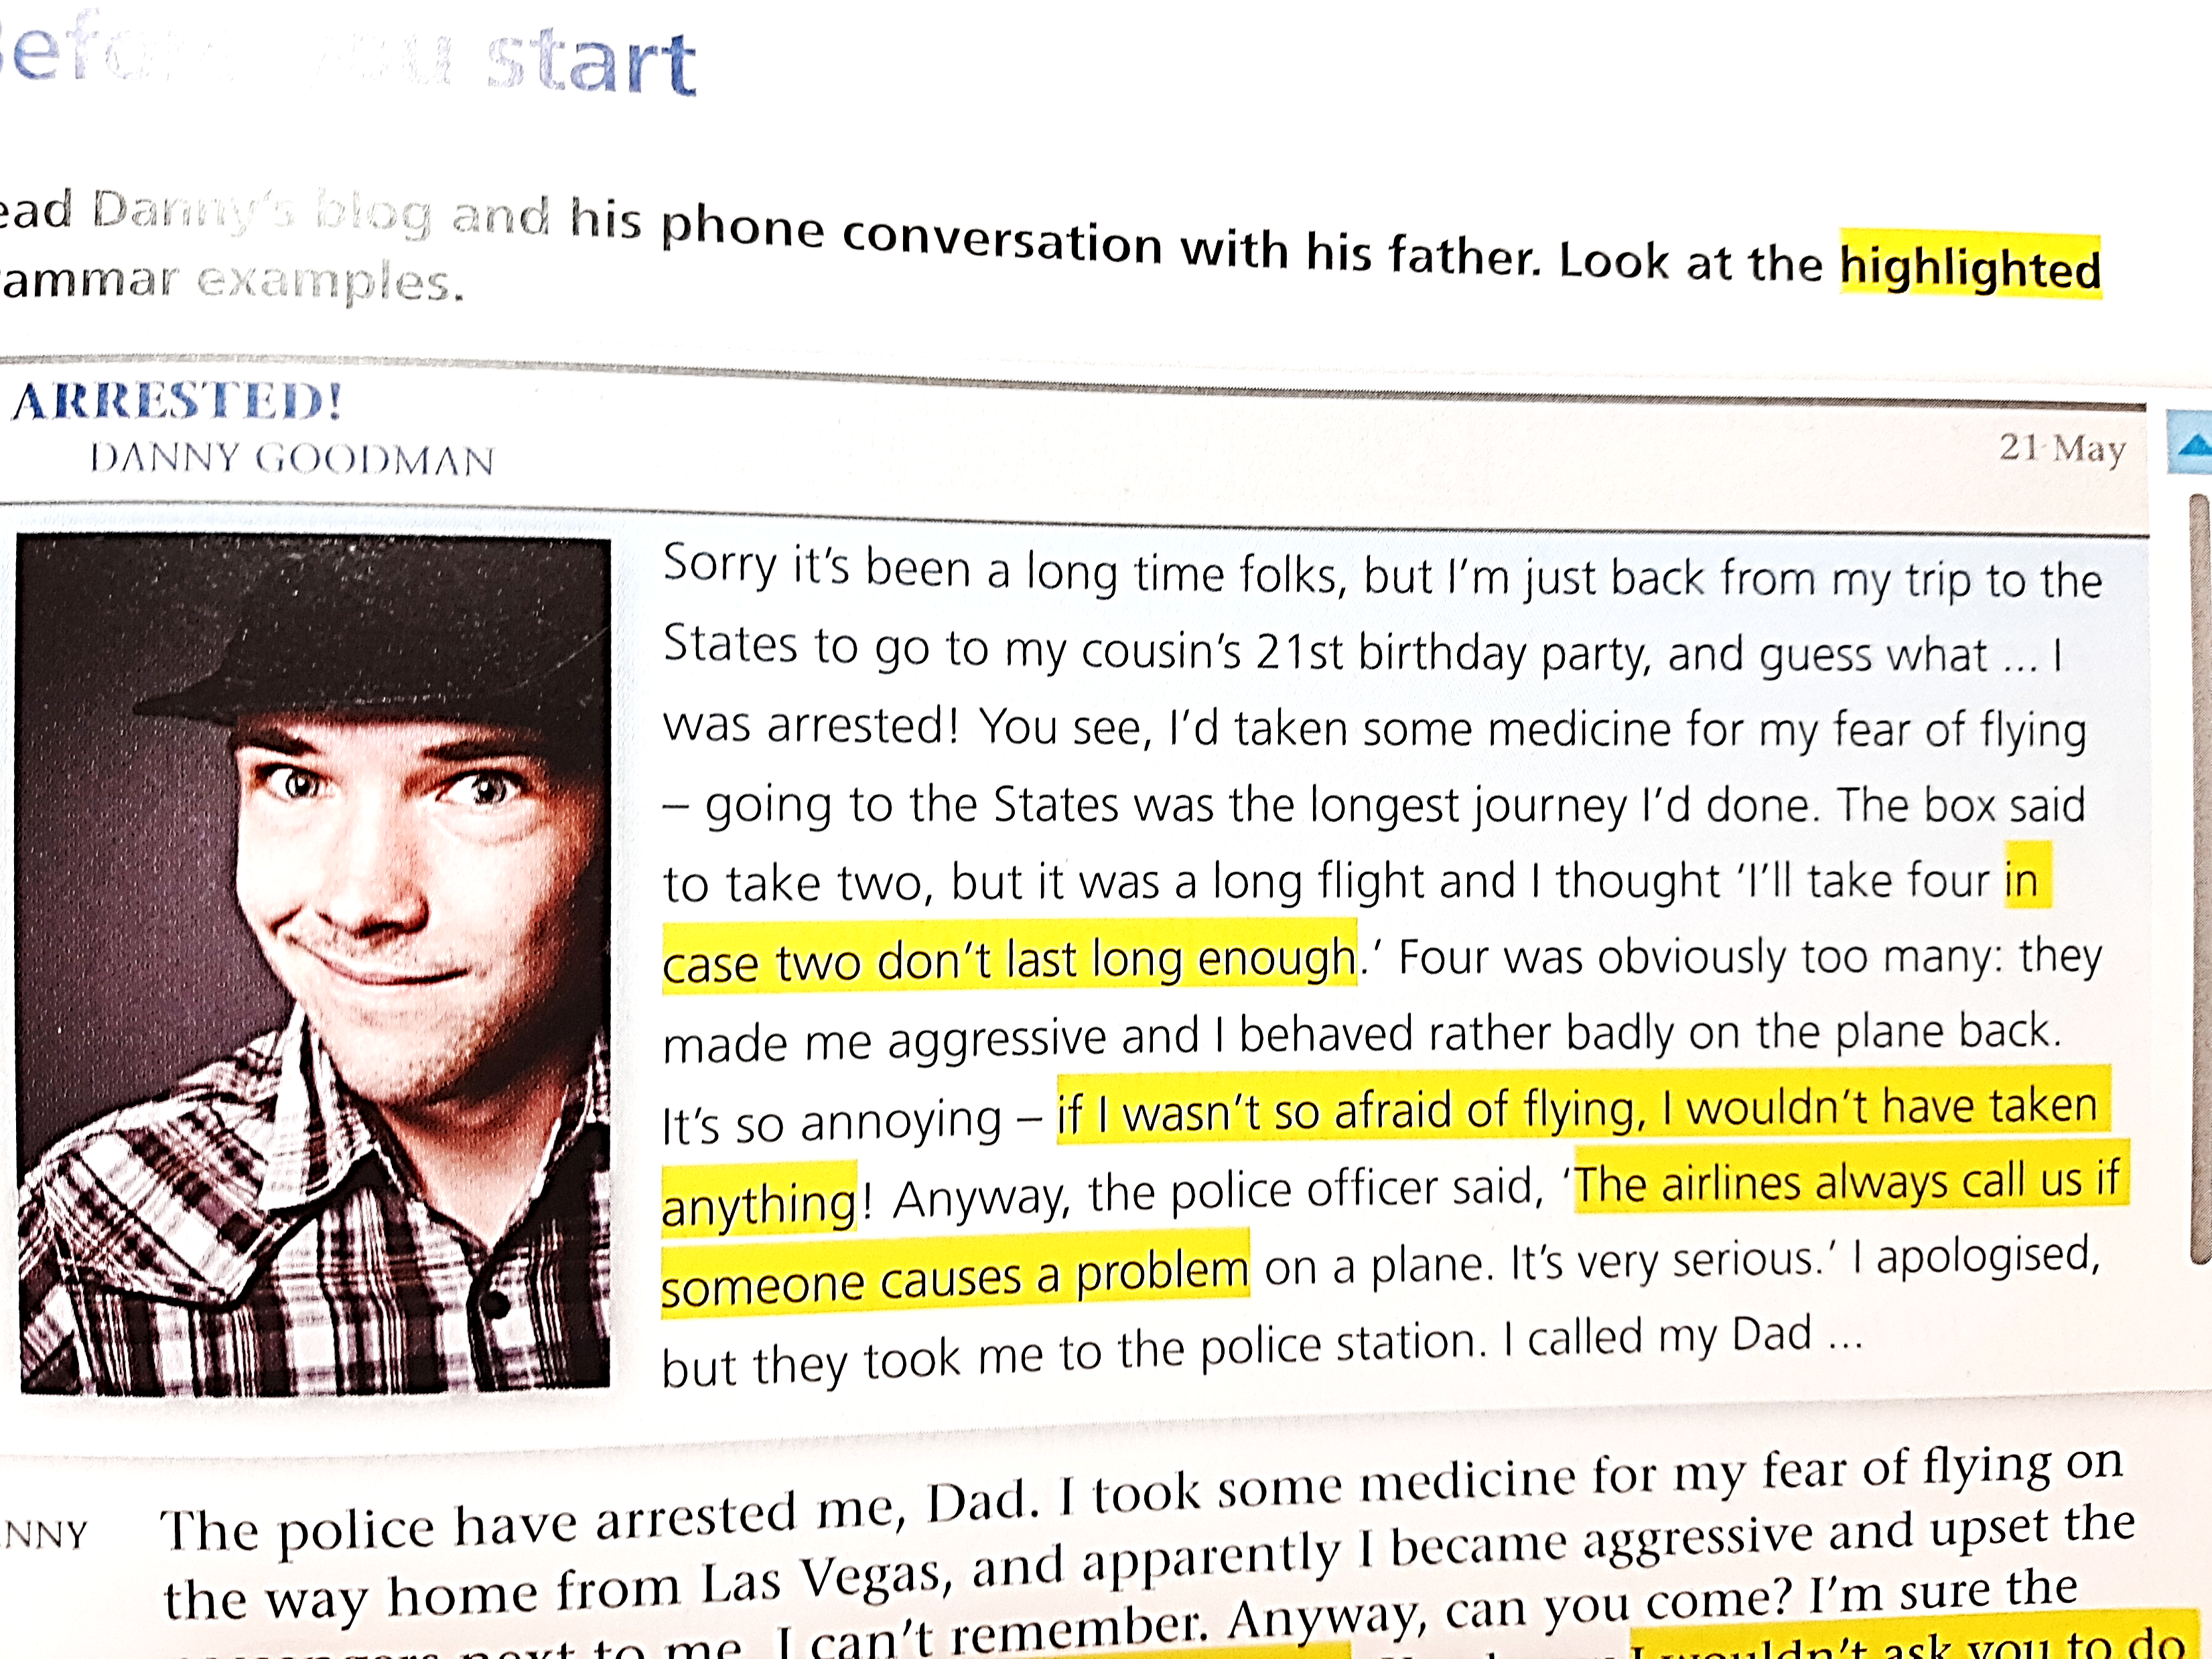

**Read Danny’s phone conversation with his father and look at the highlighted grammar examples.**

**Do they describe future, present or past situations? Real or unreal situations?**

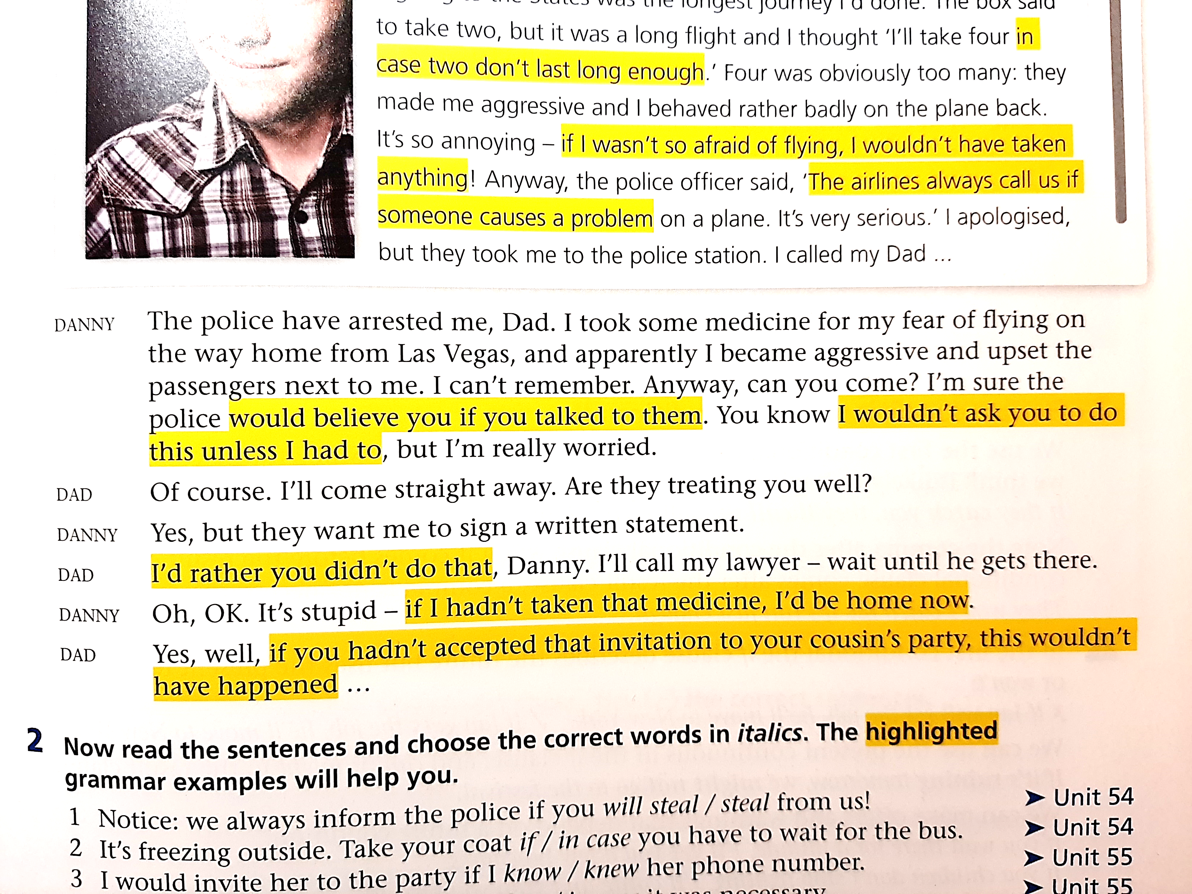

(from the textbook “Grammar Lab”)